
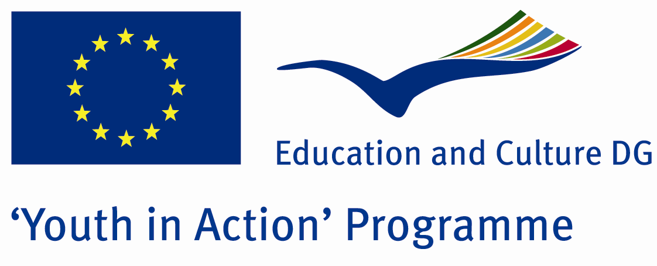

Organization for Scientific and Practical Development of the Students
onprs09@gmail.com
„Central and Eastern Europe – Together towards the European Idea”
Arbanassi, Bulgaria
20th November – 1st December 2010

APPLICATION FORM
Action 1.1 - Youth Exchanges

Deadline for applications: May 28th, 2010
Apply at onprs09@gmail.com

Please, provide us with brief information about your organization, interests, experience and expectations about this exchange. Just fill in the following sections and send this application form back to us at onprs09@gmail.com

Sofia, Bulgaria 2010
I. Information on the applicant
Name of the organisation:
Contact person:
Position:
Registered address:
Postal code:
City:
Country:
Contact phone number:
Fax number:
E-mail address:
Web site:

II. Experience and Interests

- Your experience with the Youth in Action Programme
Please describe the projects that you have been coordinating or participated in and list other projects realized within Youth in Action Programme that you’ve been involved in. Also, point out your interests, goals etc.

- Expectations and Motivation
Please describe very briefly your expectations towards this exchange and your motivation - why do you want to participate in? What do you expect to gain from the participation in the project? How do you intend to contribute to the project?

Thank you for taking the time to fill in this form. Please send it to onprs09@gmail.com till May 28th, 2010. For more information about the exchange refer to our Project Guide, attached to the e-mail you received from us. We kindly ask you to send us your signed and stamped Part III by the 28th of May via email to onprs09@gmail.com.
We are looking forward to your applications.
Kind regards,
Krasimir Petkov, Project Manager
Organization for Scientific and Practical Development of the Students
“Osmi dekemvri” Str., Block 23A
Studentski grad,
Sofia, Bulgaria
onprs09@gmail.com

